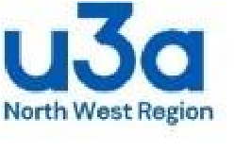
North West Region of u3as
Charity Registration no 1159091

SPEAKER FORM
NAME
EMAIL
PHONE

I agree to my contact details being displayed on the u3a Region website: - tick box YES
Brief synopsis (30 words max) or link for further reference (email, website….)

Please indicate type of presentation: Zoom in person
FEE (state negotiable if appropriate)

Are you a u3a member? YES NO
Please note that u3as cannot pay a fee to u3a members. Expenses can be covered.
We require a recommendation from a group you have spoken to. Please contact the group and ask them to send this to secretary@nwru3a.org.uk
Please send your completed form to the NW Region Secretary. secretary@nwru3a.org.uk
You can also update your entry by contacting the secretary.
__________________________________________________________________________________________
NW region committee only:

Group recommending:

Date received:

